**HBEC Candidate Starter Kit for Tablet-based Electronic Data Collection ● July 10, 2018**

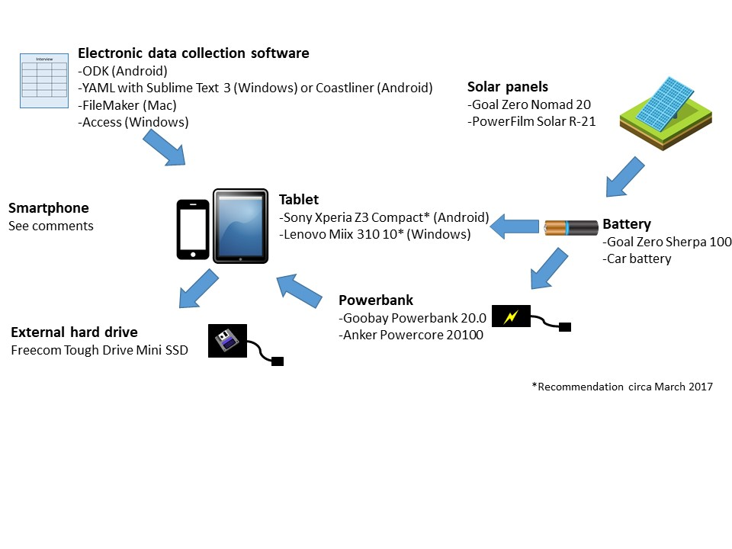

**Software**: After field-based testing, we recommend two open-source options: [ODK](http://opendatakit.org/) and direct entry in [yaml](http://yaml.org/) (with direct entry to yaml using a text editor on any device (e.g., Sublime Text 3 on Windows). ODK is better than yaml for research assistants, as it is automated and more forgiving than direct entry in yaml; however, yaml may be the preferred option for those familiar with coding and text entry. For those who prefer paid software with customer support staff, we also have experience with electronic data collection via FileMaker Pro and Access, which have worked well for a number of us.

**Tablets**: In 2017, we researched two tablets: the Sony Xperia Z3, an Android tablet (e.g., if you intend to use ODK or yaml; model SGP621), and the Lenovo Miix 310 for those looking for a Windows tablet (e.g., if you intend to use yaml or Access). We liked the Sony tablet because it’s waterproof and has a 15-hour battery life. The Lenovo has a similar battery life and a detachable keyboard. However, our test run of the Sony in the field was iffy – our test user had issues with data transfer – and the Lenovo is no longer available. In the past, we’ve also loved the Dell Venue 8 Pro, but this too is no longer available. We recommend devices with similar specs: long battery lives, not too big (10” max), and waterproof when possible. Another reason to consider an Android tablet is that they both have built-in GPS, which can be useful for noting the location of an interview (e.g., in ODK or yaml), and they accept SIM chips, which can enable you to backup your data over a 2G, 3G, or LTE connection. (Check candidate devices on [Frequency Check](https://www.frequencycheck.com/) before purchasing to make sure they work in the country where you do research.) Consider purchasing a rugged case for your tablet if it might be subject to falls.

**Smartphones:** Smartphones cannot be underestimated as a powerful tool for field research. They take photos, they have GPS for marking locations, and they have SIM cards for data backup over a connection. They can also be easier to use for research assistants who have more experience with smartphones and less with computers. In general, we recommend cheap phones (which tend to be Androids), as they are more expendable. However, if phones are hard to replace at your site, you may wish to consider whether phones are waterproof, have long battery lives, and are “rugged” (that is, resistant to crushing and falls). Even with cheap phones, consider a protective case to protect the phone from falls.

**External hard drive**: In addition to backing up your data online whenever you have a chance, we recommend backing up to local hardware such as flash drives and external hard drives. You may want to consider backing up to one of each: for example, backing up all your files (including the biggest ones, like videos or 3D scan data) to an external hard drive and only the smaller files (such as surveys, photos, and voice recordings) to a flash drive you keep on your person. External hard drives come with a range of different features; as you are the person most familiar with your field site, you are the best judge of whether you need a really hardy external drive or can get by without the extra bells and whistles. One device we tried and liked was the [Freecom Tough Drive Mini SSD](https://www.freecom.com/products/tough-drive-mini-ssd/). In general, SSDs are better for the field because they are less prone to damage from falls. The Freecom comes with an anti-shock frame and is nice and small, unlike other hard drives we have field tested.

**Powerbank**: Even with a long battery life on your field tablet, you don’t want to be caught off-guard with a dying battery. Having a powerbank on hand can alleviate that concern. The [Goobay Powerbank 20.0](https://www.conrad.de/de/powerbank-zusatzakku-goobay-powerbank-200-lipo-20000-mah-1511499.html) is a hefty (yes, beware: 430 grams) battery unit that can charge your tablet even while you’re using it. We also like the [Anker PowerCore+ 20100](https://www.anker.com/products/A1371012). 430 grams seem like a beast? Try a smaller powerbank for a quick boost, but not a full recharge (e.g., [PowerCore+ 10050](https://www.anker.com/products/A1310051)).

**Solar panel and battery**: No electricity, or inconsistent electricity, at your site? Electronic data collection is still do-able if you get some sunlight! The [Goal Zero Nomad 20](http://www.goalzero.com/p/179/nomad-20-solar-panel) and [PowerFilm R21](http://www.powerfilmsolar.com/products/?r21__21_watt_rollable_solar_panel&show=product&productID=271517) have both been used long-term in the field by members of our department, and we’re fully satisfied. The Goal Zero is water resistant – it’s been rained on numerous times with no trouble thus far – and fits in a standard daypack (e.g., Jansport-sized backpack). The PowerFilm is designed for sea vessels and is fully waterproof and rollable: you can roll it up and pack it in your checked luggage. We recommend daisy chaining solar panels – either two R21s, or two Nomads, connected together – to charge your solar battery more quickly when it is sunny. The PowerFilm can be connected to car battery purchased in the country where you do research using an [R9 charger controller](https://www.powerfilmsolar.com/products/ra-9-charge-controller). As far as solar batteries go, we have used and liked the [Goal Zero Yeti 150](http://www.goalzero.com/p/352/goal-zero-yeti-150-solar-generator-220v) in the past, but American and British carriers no longer will transport a battery this large (for European operators, it depends on the airline: contact them to check their policy). An alternative is the [Goal Zero Sherpa 100](https://www.goalzero.com/shop/sherpa-power-banks-and-accessories/sherpa-100-power-bank-inverter/), which is the maximum allowable wattage you can carry on American and British airlines. Our field testing suggests that in sunny conditions with two chained Nomad panels, the Sherpa can fully charge a laptop and several smartphones daily. The Sherpa stops accepting a charge automatically when full (no need for a charge controller) and can charge devices directly through an on-board USB plug. You will need to use an [RA16 adapter](http://www.powerfilmsolar.com/products/?ra_16__3ft_extension_adapter_with_475mm_barrel&show=product&productID=271567&productCategoryIDs=6574) to use PowerFilm panels with Goal Zero products.